Atoms and Periodic Table Unit Name:

Due Date:

|  |  |
| --- | --- |
| How are you and a picture of hot gases swirling around our universe billions of years ago connected? |  |

|  |  |
| --- | --- |
| How small is an atom? | Describe the sub atomic particles below. |

|  |
| --- |
| Please describe Rutherford’s gold foil experiment using the diagram below. What did it show? Use the box on the right to draw a close up of what it found.    Can you describe a cathode ray tube experiment below?  -  + |

|  |  |
| --- | --- |
| Please draw your best atomic cloud. Remember, and atom is mostly _________ space. | Please give the particles below the correct charge. |

Please fill in the boxes with all of the correct information using the periodic table of the elements.

|  |  |  |  |  |  |  |  |
| --- | --- | --- | --- | --- | --- | --- | --- |
| Protons ( P+)+ –  Electrons (E-)–  Neutrons (No)   |  | | --- | | Li | | Protons – 6  Electrons – 6  Neutrons-   |  | | --- | |  | | Protons –  Electrons –  Neutrons-   |  | | --- | | Ne | | Protons –  Electrons –  Neutrons-   |  | | --- | | 11 | |

Please fill in the boxes with all of the correct information using the periodic table of the elements.

|  |  |  |  |  |  |  |  |
| --- | --- | --- | --- | --- | --- | --- | --- |
| Protons –  Electrons – 13  Neutrons-   |  | | --- | |  | | Protons – 17  Electrons –  Neutrons-   |  | | --- | |  | | Protons –  Electrons –  Neutrons-   |  | | --- | | Ca | | Protons –  Electrons –  Neutrons-   |  | | --- | | 29 | |

|  |  |
| --- | --- |
| Please draw a picture of Hydrogen and label the protons, neutrons, and electrons with the correct charge. Use P+, No, E-.  Please correctly label the dense hard core with its proper name. | Please draw a picture of Aluminum and label the protons, neutrons, and electrons with the correct charge. Use P+, No, E-.  Please correctly label the dense hard core with its proper name. |

|  |  |
| --- | --- |
| Please name and accurately show the fundamental particles that make up a proton. | Please name and accurately show the fundamental particles that make up a neutron.  I hold Quarks  Together |

Please put the following in the correct box according to their size.

|  |
| --- |
| Atom Electron Quark Proton Neutron Molecule Nucleus |

Smallest ---------------------------------------------------------🡪 Largest

|  |  |  |  |  |  |  |
| --- | --- | --- | --- | --- | --- | --- |
|  |  |  |  |  |  |  |

What am I and all matter made of?

A correct answer dives deep into the recipe of the universe.

|  |  |
| --- | --- |
| Hint- You may want to complete the question below first. | ____________________________________________________  ____________________________________________________  ____________________________________________________  ____________________________________________________  ____________________________________________________  ____________________________________________________  ____________________________________________________  ____________________________________________________  ____________________________________________________  ____________________________________________________  ____________________________________________________ |

Please complete the blank standard model in particle physics below.

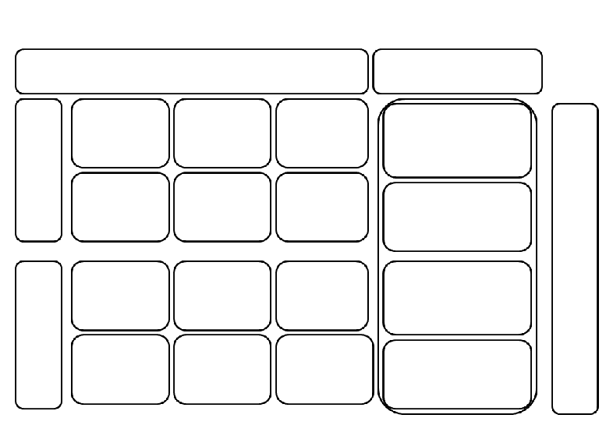

Please make some reference to John Daltons Atomic Assumptions in the space below.

|  |  |
| --- | --- |
|  |  |

Please record the number of electrons that inhabit the first four energy levels (shells) for the first 18 elements.

|  |  |  |  |
| --- | --- | --- | --- |
|  |  |  |  |

Please record in large bold numbers the number of **valence electrons** beneath the elements below.

|  |
| --- |
|  |

Please label the mystery elements below with the correct atomic number, symbol, name, and atomic mass around the image

|  |  |
| --- | --- |
|  |  |
|  |  |

Please create an electron dot structure for the following elements.

|  |  |
| --- | --- |
| Symbol (Ar) | amu = 19.00 |
| I have 12 Electrons in my nucleus. | Atomic number # 14 |

Please complete Lewis Dot Structures for the following molecules

|  |  |  |
| --- | --- | --- |
| H2O | C2H6 | CH4 |
| NH3 | AlH3 | NaCl |
| Draw another hydrocarbon  of your choice | Please create an alcohol | Nitrogen gas N2 (triple bond) |
| CO2 | What is group of nitrogenous organic compounds that are an essential part of living cells | C2OH6 (Ethanol) |

Please describe the difference between ionic and covalent bonds based on the picture below.

|  |  |
| --- | --- |
|  |  |

Please label as ionic, covalent, or metallic bond (Anion? Cation?)

|  |  |  |
| --- | --- | --- |
|  |  |  |

Please record the type of bond based on electron negativity differences.

Nonpolar Covalent, Polar Covalent, Ionic (Use your periodic table)

|  |  |  |
| --- | --- | --- |
| CH4 | CO2 | H2O |

Please try and balance these two unbalanced chemical equations.

|  |  |  |  |  |  |  |  |  |  |  |  |  |  |  |  |  |  |  |  |  |  |  |  |  |  |  |  |  |  |  |  |  |  |  |  |  |  |
| --- | --- | --- | --- | --- | --- | --- | --- | --- | --- | --- | --- | --- | --- | --- | --- | --- | --- | --- | --- | --- | --- | --- | --- | --- | --- | --- | --- | --- | --- | --- | --- | --- | --- | --- | --- | --- | --- |
| ____ H2 +___ O2 🡪 ___ H2O  Inventory Box   |  |  |  | | --- | --- | --- | | Element | Before | After | |  |  |  | |  |  |  |   Inventory Box   |  |  |  | | --- | --- | --- | | Element | Before | After | |  |  |  | |  |  |  | | ___ Al +___Cl2 🡪 ___AlCl3  Inventory Box   |  |  |  | | --- | --- | --- | | Element | Before | After | |  |  |  | |  |  |  |   Inventory Box   |  |  |  | | --- | --- | --- | | Element | Before | After | |  |  |  | |  |  |  | |

Please describe and provide one example of each below. Providing a balanced chemical equation would be awesome.

|  |  |
| --- | --- |
| Exothermic Reaction | Endothermic Reaction |

Please describe which arrow represents oxidation, and which represents reduction in the equation below. (LEO says GER) (OIL RIG)

CO + H2O 🡪 CO2 + H2

Reduction is loss of oxygen.

Oxidation is gain of oxygen.

Can you balance this equation and then describe which is oxidation and which is reduction by creating and labeling your own arrows.

___Al(*s*) + ___Fe2O3(*s*) 🡪 ___Al2O3(*s*) + ___ Fe(*l***)**

Please describe how this arrangement of playing cards relates to the periodic table of elements.

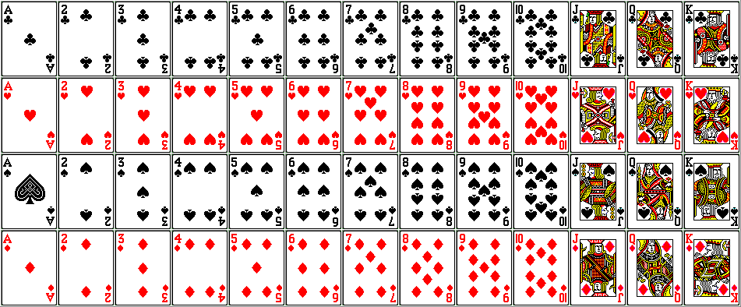

**Warning 5 part question!** Check each diamond when complete

◊ **Color code** the following: Noble Gases, Non-Metals, Metalloids, Alkali Metals, Halogens, Alkaline-Earth Metals, and Transition Metals.

◊ Record the number of valence electrons in each period.

◊ Next to period 1, 2, 3, 4, 5, (make a sketch of the number of electron orbitals)

◊ Draw arrows showing the direction of increasing atomic number and atomic mass

◊ Show an arrow showing increasing electron negativity.

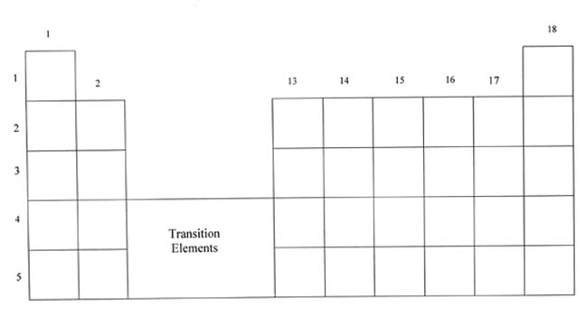

Key

( ) ______________ ( ) ______________ ( ) ______________

( ) ______________ ( ) ______________ ( ) ______________

( ) ______________ ( ) ______________

Please describe unique properties of metals, non-metals, and metalloids in the correct boxes below. Use ductile, malleable, luster, electrical conduction, and other property that you know.

|  |  |  |
| --- | --- | --- |
|  |  |  |

Please explain the cartoon below with a few sentences beneath.



Please visit the class periodic table of elements and record information about elements in the space below. Please describe the elements uses, unique properties, isotopes, location of earth, etc.

|  |  |  |
| --- | --- | --- |
|  |  |  |
|  |  |  |

Please record some of the basics of the letters below

|  |  |  |  |  |  |
| --- | --- | --- | --- | --- | --- |
| S | P | O | N | C | H |

|  |  |
| --- | --- |
|  | Name:_______________________ |

**Atoms and Periodic Table Unit Crossword**

1

2

3

4

5

6

7

8

9

10

11

12

13

14

15

16

17

18

19

20

21

22

23

24

25

26

27

28

29

30

31

32

33

**Possible Answers:**

Alcohol, amu, Atom, Atomic, Bonding, Carbon, Covalent, Dalton, Ductile, Elements, Group, Hydrocarbon, Ionic, Ionization, Isotope, Leptons, Malleable, Mass, Metallic, Metalloids, Metals, Neutron, Neutrons, Nonmetals, Nucleus, Particles, Period, Protein, Proton, Quarks, Rutherford, Six, SPONCH, Transition, Valence

|  |  |
| --- | --- |
| **Across:** | **Down:** |
| 3 - Metals are considered this if they can be made into sheets.  7 - A _______________ is a vertical column on The Periodic Table of the Elements  8 - Everything in the universe is made of 6 Quarks, 6 Leptons, and Force Carrier __________________.  10 - The positively charged dense center of an atom.  13 - Organic compound consisting entirely of hydrogen and carbon.  16 - This scientist created the atomic theory  18 - This is a positively charged particle composed of two up quarks, one down  19 - Abbreviation for Atomic Mass Units. The number of protons, neutrons, and electrons.  21 - Type of bonding where atoms share many free electrons  24 - Electron’s in the outer most shell.  25 - These are good conductors of heat and electricity. They also have luster and a high density  27 - Metals are considered this if they can be made into wire.  29 - There are this many known quarks?  30 - The attraction that holds atoms close to each other  32 - Group of nitrogenous organic compounds that are essential parts of living cells.  33 - Atoms are arranged on The Periodic Table of the _____________. | 1 - Protons and neutrons are composed of even smaller particles called quarks  2 - To find the number of __________: Subtract the atomic number from the atomic mass  4 - Mostly carbon and hydrogen with a OH group  5 - These types of metals are found in the middle of the Periodic Table.  6 - These have properties of both metals and nonmetals.  9 - This particle has a no charge and is composed of two down quarks, and one up quark.  11 - # 6 on The Periodic Table of the Elements  12 - Atom with same number of protons and electrons but different numbers of neutrons  14 - Type of bonding where atoms share electrons  15 - The process of removing electrons from an atom to form ions  17 - Atoms always have the same number of protons and electrons, this called the ___________ number.  18 - A _______________ is a horizontal row on The Periodic Table of the Elements  20 - Used a gold foil experiment to help understand the structure of the atom.  22 - This is the smallest part of an element which can take part in a chemical reaction.  23 - These are brittle, poor conductors, have no luster, and can be a (s) (l) (g).  25 - The Nucleus has almost all the ______ of the atom.  26 - The six _____________ consist of the Electron, Muon, Tau, and 3 types of Neutrinos  28 - The six biologically important elements.  31 - Type of bonding where an atom gains or loses electrons (+/-) |

